Title: Quadratic Solver
Date: February 19th, 2019
Team: Tim Hinga and Andrew Crowley
Contact: John Kapenga

Abstract:
This program will act as a quadratic equation solver, where a user will enter 3 different values, and the program will then return either 2 real roots, or indicate that there are 0 real roots.
Shown below is the quadratic formula. The user will enter values for a, b, and c. Then, the program will return values for x.

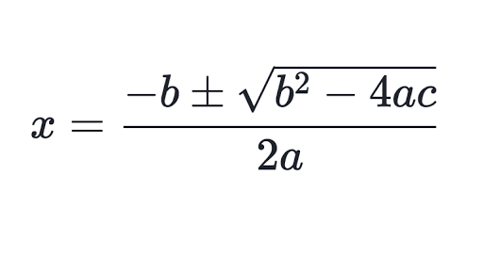

Stories:
- Engineer starts Quadratic Solver program on command line and is prompted to enter values.
  - Time estimated to complete: ~1 hour

- User then enters values for a, b, and c.
  - Time estimated to complete: <1 hour

- Program will read the input from the user, check the validity of the input values, and convert them to doubles if the values are acceptable, otherwise the program will ask the user to re-enter with different values.
  - Time estimated to complete: ~1 hour

- Quadratic Solver checks that a, b, and c are IEEE-FP normalized 32-bit floats. Will report if a, b, and c are out of range. Warns if a, b, and c have extra digits.
  - Time estimated to complete: 1-2 hours

- Program will use the quadratic formula with a, b, and c, and then returns x1 and x2, or indicates that there are no real roots.
  - Time estimated to complete: ~1 hour

- In case of possible rounding errors, then program will issue a warning.
  - Time estimated to complete: <1 hour

- Program will then prompt the user and ask if they want to use the solver again, or if they want to exit. Program will then either prompt the user for more values, or will terminate.
  - Time estimated to complete: <1 hour

